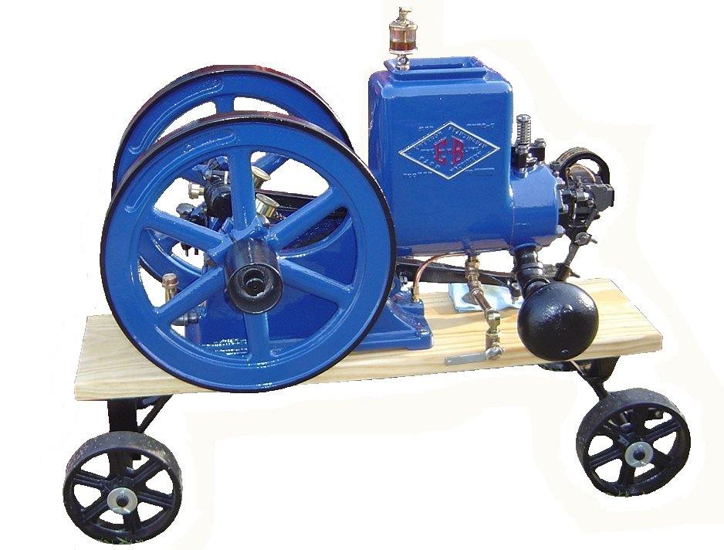
F O O T H I L L S

ANTIQUE POWER ASSOCIATION
ESTABLISHED 2003

Dear Members, April 2016
It’s almost here – only a few weeks to go, and those few days will pass before we know it. Much is being done now in preparation, but much is yet to be done.

--- --- --- From the April Meeting --- --- ---

- We continue to have many who are in need of special prayer. We trust God to care for them as only He can, whether it be healing, or for comfort and strength to living in the midst of affliction. We cast our cares on Him, for He cares for us.

  - Kelly Blanton
  - Dot Hawn
  - Butch Minyard
  - Rev. Bobby Langston
  - Allen Everdyke
  - Lorna Sheets
  - Charles Huffman
  - Steve Hefner

  - Wade Hefner
  - Norris Turner
  - Don Johnson
  - Carl Porter
  - Jane Abernathy
  - Terry Martin
  - Eugene Hartley
  - Ira & Ann Cline
  - Carroll Hilliard
  - Howard Cooper
  - Charles Elmore
  - Ann Little
  - Charles Bentley
  - Kenneth Beach
  - Powell Sigmon
  - Howard & Vee Williams

- In the past month we lost two of our members: in early March, Charles McRee fell asleep and, the day after the April meeting we got word that Rupert Little passed away.

- If you have not renewed your membership for 2016, you can still do so. Remember, being up-to-date on your membership is a primary criteria for being able to reserve a space at the show. (Additional notes on reserved spaces are below.)

- All ads need to be in now. If they are not received by April 15 AT THE LATEST, they will not get into the program.

--- --- --- Show Preparations --- --- ---
- The Tee-shirts are printed and will soon be ready for sale. During the next Show Committee meeting we’ll be folding and sorting them and getting them ready for the show.

- A few specific items need to be emphasized as we come down to the wire.

  - For all members having reserved spaces at the fairgrounds, we will do the same as last year: if you have not placed your equipment on your space by Friday at noon, the space(s) will be reassigned as needed for the remainder of the show, that is, unless you inform Teddy Hefner or Anthony Austin that you will be late arriving.
    - If you have not used your space in some time, please consider relinquishing it so someone else can use it. Let Teddy or Anthony know. We are considering canceling specific reserved spaces if they have not been used in a couple years – it’s only fair, if you don’t want to use your space, someone else can.
    - If you cannot to use them this year, please inform Teddy or Anthony also, so he can temporarily provide someone else the opportunity to show their equipment this year. We want to do all we can to fill the display area.

  - Everyone planning to use electric power during the show – vendor, exhibitor, member or non-member – is required to pay a $25 power fee. This is not our requirement, but the fair board and the funds collected go directly to the fair treasury to pay the electric power bill. Charles Bentley is in charge of collecting these fees. If you do not pay him ahead of time, he will find you during the show and collect the fee!

  - Golf carts will once again be available. If you’d like to rent one for the weekend, go ahead and contact Golf Carts of Hickory, and he’ll set you up. At the show, Candy Richey and Howard Reinhardt will be handling daily rentals.

  - On the last page of this letter you will find a list of guidelines and rules we need to all be aware of and adhere to so we can make sure our show is a safe and pleasant one for everyone. Please familiarize yourself with them.

☺ ☺ !!!!! HAPPY BIRTHDAY !!!!! ☺ ☺

April birthdays

1 – Richard Blume
1 – Johnny McCaslin
1 – Duane Webb
2 – James Reinhardt
3 – Bobby Franklin
3 – Dexter Sprouse
4 – Brent Henley
6 – Dennis Back

6 – Bryan Warner
9 – Chuck Smith
12 – Charles Lynch
16 – Johnny Hollar
16 – linda Sigmon
17 – Blake Herman
19 – Michael Dagenhart
19 – Debbie Yelton
20 – Sam Erby
21 – Fred Little
26 – Kermit Nash
28 – Angela Schronce
30 – Butch Fox
30 – Kyle Sigmon


May birthdays

1 – Ben Elmore
2 – Allen Keller
3 – Jason Ball
4 – Jason Dagenhardt
7 – Terry Rodland
8 – Jimmy Milsaps
20 – Brad Hawes
24 – Donna Lauterbach
24 – Dylan Roseman

25 – Paul Pope
28 – Gene Carpenter
29 – Clark Davis
30 – Gale Wilson

-- --- --- THE CLASSIFIEDS --- --- ---

Is there anything you would like to sell or are you looking for something special? List it here.
(Item listings will run for 3 months before expiring. Let us know when an item is sold or bought.)

FOR SALE

1948 Ford 8N, fully restored, 828-323-5743 (16-03).

1939-54 Ford front bumper, $100 828-612-2059 (15-03).

--- --- --- UP-COMING EVENTS --- --- ---

April 15 Catawba FFA Ag Day at Bandys High School
April 16 Mt. Grove Baptist Ch. Spring Fest
April 18 West End Equipment Spring Show
April 21 Sig’s Show Committee meeting
April 21-24 Gray TN Tri-County Show
May 5 Sig’s monthly meeting
May 6-7 Morganton Valley Hills Antique Power Show
May 7 Conover Southern States Grand Opening
May 7 Taylorsville Apple Blossom Festival
May 20-21 Newton FAPA 13th Annual Antique Power Show

--- --- --- something to think about --- --- ---

A couple months ago, we spoke about changes. Some think there is no need for it, but change is what God has asked us to do.
Romans 12:2 says we are not to conform to the world, but be transformed by the renewing (or remaking) of our minds so that we can prove what is God’s will. This means we are to change how we think and what we think. Once that change is made, we can then change what we say and do to be in accordance with His will. It cannot be the other way, that is, change our actions first – that simply will not work.
We were born into this world a blank slate and we learned over the years all we know about how to live in this world. Having been born again into God’s family, are we to expect that all we have learned so far in this world is going to help us live righteous and holy lives in God’s presence? If so, why did God say we are to change? If this is His command to us (and it is), are we to continue ignoring it in favor of what we want to do? Do we even know what it means to change our minds?
Ask yourself these questions. “Am I willing to say: I do not know?” “Am I willing to say, I do not know all there is to know?” “Am I so trusting of others that I take what they tell me at face value, assuming it is always true, or do I endeavor to prove it?”
There is no shame in saying, “I don’t know.” We should also not trust everyone who says, “thus saith the Lord.” The Old Testament is filled with examples of lives being lost or destroyed because of what turned out to be lies or simply because they did not know.
God wants us to know – He wants us to know Him (John 17:3). He is ready and willing to give us all we need to know to life live with Him. All we need do is ask and be ready to change when He teaches us something – and He will!
God bless you all. See you in May. Your Secretary,
David Setzer

5851 St. Peter’s Ch. Rd. Conover, NC 28613 --- www.foothillsantique.com

President: Kevin Black 828-464-1950 Vice Pres: Wilson Sigmon 828-256-2176
Treasurer: Kermit Nash 828-459-9616 Secretary: David Setzer 828-850-4943
Show Chair: Ned Story 828-464-6399 Asst.Show Chair: Teddy Hefner 828-310-5525
Asst. Secretary: Kevin Sigmon 828-256-2176

Board of Directors

Philip Spencer Teddy Hefner Tim Hollar Butch McIntyre Howard Reinhardt Ned Story

Foothills Antique Power Association 13th Annual Power Show May 20 – 21, 2014

- Set-up time at the American Legion Fairgrounds will begin Thursday afternoon May 19th after the Flea-market clean-up has been completed and the grounds have been prepared. Actual time for opening the gates for setup may be between 4 or 5PM depending upon when clean-up is completed. If it is finished early, the time can be moved up.
- Spaces in the main exhibit area may be reserved by members in good standing (dues paid). These spaces are to be occupied by 12 noon on Friday May 20 or they will be forfeited for the duration of the show (unless your intent to fill them after that time is communicated to the reserved space coordinator – Teddy Hefner (310-5525).
- All members are to be aware of and adhere to the safety requirements for the show.
- All members are called upon to function as safety monitors by presenting your own exhibits in a safe manner and helping each other do the same.
  - All equipment is to be chocked when parked. Chocks will be available if you have none.
  - Fire extinguishers are to be ready at hand.
  - Be aware of and yield to pedestrians when driving any vehicle on the grounds.
  - Demonstrations should be roped-off to keep little fingers on little hands where they belong.
- Plenty of parking is available, but we need to utilize it wisely.
  - Trailers should be parked in the area behind the livestock barn.
  - Towing vehicles should be parked in the general parking area.
  - The area next to the pulling track is for pullers (Friday & Saturday)
- All exhibitors are encouraged to register.
- All exhibitors are encouraged to operate their equipment during the show except for two specific times. During these times, all engines, tractors, mowers, etc. are requested to be turned off.
  - During opening ceremonies on Saturday morning.
  - During Sunday morning church services.
- The route for the Parade of Power will be marked off with signs. Everyone should begin by exiting the Main Exhibit area through the pulling track parking area, cross the main road and proceed through the main parking area to the back gate, then through the food court area.
- This is our show. That means we are host to the public and to those who come to exhibit with us. It is up to every one of us to do what we can to make it a memorable experience for all who come. Each member is encouraged to do their part – no task is too small or menial to be worthwhile and every person is worthy of a smile or a helping hand.
- Basic schedule of events
  - Friday: Lawn mower pull - 7PM
  - Saturday:
    - Opening Ceremony - 9AM,
    - Kiddie Pull – 10AM,
    - Demonstrations – 10AM thru mid-afternoon
    - Parade of Power – 1PM
    - Tractor Rodeo – 3PM
    - OTTPA Truck/Tractor Pull – 5PM
  - Sunday:
    - Church service – 9:30AM

